
Software Requirements Specification
CAFETERIA ORDERING SYSTEM

03/18/2017

Prepared by
TechnoRockerz

- Charushila Awhad
- Ketaki Shikarpur
- Sonal Patil
- Saranya Arunachalam

Table of content

1. Introduction 2
1.1 Scope 2
1.2 Definitions, acronyms, and abbreviations 2
1.3 References 3
1.4 Overview 3
2. Overall Description 3
2.1 Product Perspective 3
2.2 Product Features 3
2.3 User Classes and Characteristics 4
2.4 Operating Environment 5
2.5 Design and Implementation Constraints 5
2.6 User Documentation 6
2.7 Assumptions and Dependencies 6
3. Use Case Diagram with Use-case description 7
4. External Interface Requirements 26
4.1 User interface 26
4.2 Hardware Interfaces 26
4.3 Software Interfaces 26
4.4 Communications Interfaces 26
5. Other Nonfunctional Requirements 27
5.1 Performance Requirements 27
5.2 Safety Requirements 27
5.3 Security Requirements 27
5.4 Software Quality Attributes 28
6. Other Requirements 28
7. Data flow diagram 29
8. Functional Requirements 31
8.1 FR #1 - Register an account 31
8.2 FR #2 - Place an order 31
8.4 FR #4 - Request meal delivery 32
8.5 FR #5 - Order custom meal 32
8.6 FR #6 - Order customized recipes 33
8.7 FR #7 - Provide discounts 33
8.8 FR #8 – Alter meal subscription 33
8.9 FR #9 – Provide system access 34
8.10 FR #10 – Requesting bulk orders 34
8.11 FR #11 - Provide feedback 34
8.12 FR #12 – Updating delivery man 35
8.13 FR #13 - New recipes using ingredients 35
8.16 FR#16 - Evaluate inventory status 36
8.17 FR#17 - Creating Personal menu 36
9. Sequence diagram 37
10. Class Diagram 43
10.1 Initial class diagram 43
10.2 Modified Class Diagram 45
10.3 Detailed class diagram 46

Introduction
Purpose The main objective of Cafeteria Ordering System project is to focus on the requirements by detailing the essential functional and nonfunctional requirements of the project and in addition to this it also contain the diagrammatic representation of the functionalities. The document will also describe the features and requirements for having a successful requirement specification.

Target audience

The audience are the employees who wish to order meals from the company cafeteria or from local restaurants online, the Cafeteria Ordering System is an Internet-based application that will accept individual or group meal orders, process payments, and trigger delivery of the prepared meals to a designated location on the Process Impact campus

Scope
Many employees have requested a system that would permit a cafeteria user to order meals online, to be delivered to a designated company location at a specified time and date. Such a system would save those employees who use the service considerable time and it would increase the chance of them getting the food items they prefer. This would improve both their quality of work life and their productivity. Knowing what food items patrons want in advance would reduce wastage in the cafeteria and would improve the efficiency of cafeteria staff. The future ability for employees to order meals for delivery from local restaurants would make a wider range of choices available to employees and provides the possibility of cost savings through volume purchase agreements with the restaurants. It might also permit Process Impact to have the cafeteria handle only individual lunches, relying on restaurants to fill orders for breakfasts, dinners, unique events, and weekend meals.

Definitions, acronyms, and abbreviations
SRS: Software Requirement Specification

COS: Cafeterie ordering system

GUI: Graphical User Interface

References
- Wiegers, Karl. Software Requirements Third Edition. Press: Microsoft, 2013.

- UML diagrams from: https://www.genmymodel.com/use-case-diagram-online

Overview
This document starts with project purpose and scope. It consists of overall description of cafeteria ordering system in terms of features, product functionalities, design and implementation constraints. Through this SRS document, we can classify the requirements, design, constraints and document the cafeteria ordering system. This document provides information of use case description, use case diagram, functional and non-functional requirements. The main aim of this project is to make sure that everything is noted and documented. This document has all product features and functionalities to understand it and for future reference.

Overall Description

Product Perspective
The project is based on the Cafeteria Ordering System through an application which enables the users to order meals from the main cafeteria and the other food chains around him.

Product Features
Following are the key features of the product:
FE-1 Order meals from the cafeteria menu to be picked up or delivered: The patron can order meals from the cafeteria menu. After the order has been placed the patron can choose to either pick up the meal from the cafeteria or get it delivered to the specified address.
FE-2 Order meals from local restaurants to be delivered: The cafeteria ordering system enables the patron to order meals from the local restaurants apart from the cafeteria too. After the order has been placed the patron can choose the deliver option and get the order delivered to the specified address.
FE-3 Create, view, modify, and delete meal service subscriptions: The patron can subscribe to meal services. He can also view, modify, create or delete the service subscriptions.
FE-4 Register for meal payment options: Registration for the payment is must to avoid frauds. Authentication of the credit or debit card is the reason the patron should register for the payment.
FE-5 Request meal delivery: Once the order has been placed the patron can choose the deliver option and get the order delivered to the specified address.
FE-6 Create, view, modify, and delete cafeteria menus: The menu manager is in-charge of creating, modifying, and deleting the menu options to benefit the business. Whereas, the patron can only view the menu.
FE-7 Order custom meals that aren’t on the cafeteria menu: The patron can get their order customized. The patron can get customized menus by ordering the items of his choice and preference.
FE-8 Produce recipes and ingredient lists for custom meals from cafeteria: The customized meals can be made from the recipes and ingredients that the patron provides while ordering.
FE-9 Provide system access through corporate Intranet or through outside Internet access by authorized employees: The COS application checks if the user ordering the meal is authorized or not, and if not the COS does not allow the user to continue the transaction.
FE-10: Provide discount and offers based on half day rule: After 3pm an inventory check will be carried out to have an idea about the leftover food stuffs. On the basis, of the inventory status offers and discounts will be provided for the dinner meals to avoid wastage of food.
FE-11 Provide pre-booking for bulk orders: The cafeteria ordering system will enable the patron to order bulk meals. The orders for bulk meals will be taken minimum one day prior to the delivery.
FE-12 Provide the user with the feature of giving a feedback: After the order is delivered, the patron will login into the account and provide feedback or rating about the food and restaurant which helps improve the service of the system.

User Classes and Characteristics
UC-1: Patron: A patron is a person who can view the menu, select preferred food items, customizes the meal, make bulk orders, regular orders, and make payment for the orders. The patron needs to register in the Cafeteria Ordering System to effectively use the services, order the desired food, customize it if required and to order & make payment. The patron has the option to give feedback about the food and the services.

UC-2: Manager: The manager checks and updates the menu on the daily basis. He decides the discount & exclusive offers. He adds and deletes the items from the menu and decides the prices of the items. He checks with the inventory system and provide offers. He checks the payment receipts of all the employees and maintains an account with the financial institute for all payments.

UC-3: Order processor: The patron orders customized meal or regular food on the menu using Cafeteria Ordering system and the order processor receives the order and consolidated the order and provides it to the chef for meal preparation.

UC-4: Chef: The chef receives the order details from the order processor and prepare the menu as per the quality standards. They also provide update the inventory system regarding the items in the kitchen

UC-5: Delivery Man: The patron orders, order processor registers the order and provides it to the chef for meal preparation. The manager assigns the delivery to the delivery man after the food is prepared and he follows the instructions and deliver the order to the right person at the right time.

UC-6: Financial Institute: The financial institute plays a key role as all the transactions made by the patron through the Cafeteria Ordering System are to be approved by the institute.

UC-7: Inventory System: The Inventory system checks for the available items and provides report to the manager for reviewing the menu. It reports for any items that needs to be replenished.

UC-8: Feedback analyst: The feedback analyst reviews the feedback given by the patrons regarding the food and the services provided by Cafeteria Ordering System. He checks for comments on daily basis He provides trend analysis of the ratings and have meetings with the manager for improving the services.

Operating Environment
OE-1: The product is compatible with all web browsers.

Design and Implementation Constraints
DC-1: The user interface should be user friendly and efficient which acts as a difficult challenge to the COS

DC-2: The response of the COS should be quick and responsive even while dealing with huge meal demand.

DC-3: The system should be able to deal with multiple orders both online and offline simultaneously.

User Documentation
UD-1: The Cafeteria Ordering System should provide all the patrons with the term and conditions and privacy policies.

UD-2: The homepage of the system has Help menu for helping the users with a collection of topics to understand the process of ordering if stuck half way.

Assumptions and Dependencies
AS-1: Intranet-enabled computers and printers will be available in the cafeteria to permit cafeteria employees to process the expected volume of orders without missing any delivery time windows.

AS-2: Cafeteria staff and vehicles will be available to deliver all orders within 15 minutes of the requested delivery time.

DE-1: If a restaurant has its own on-line ordering system, the Cafeteria Ordering System must be able to communicate with it bi-directionally.

Use Case Diagram with Use-case description

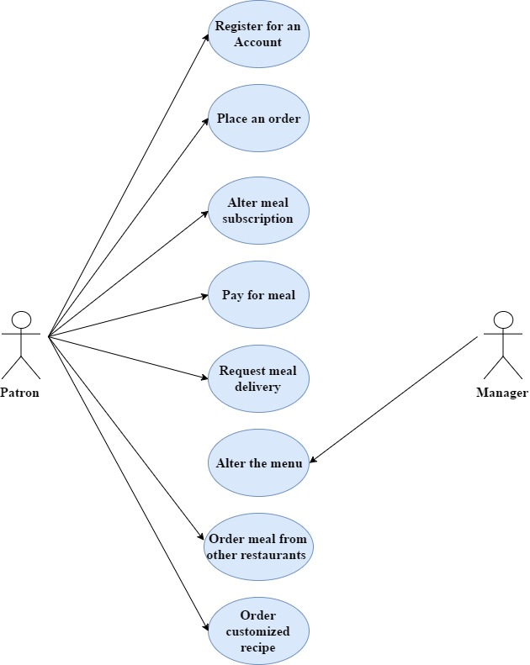

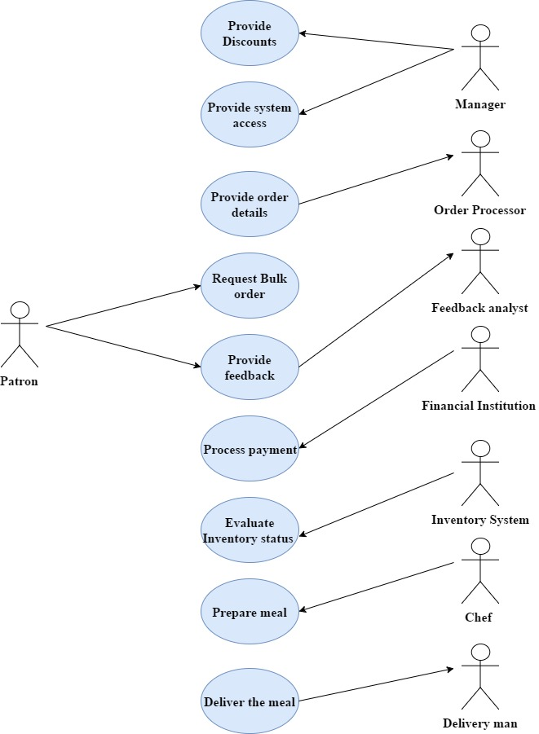

Use Case ID: | UC-1
Use Case Name: | REGISTER AN ACCOUNT
Created By: | Technorockerz |  | Last Updated By: | Technorockerz
Date Created: | 3/15/2017 |  | Last Revision Date: | 3/15/2017
Actors: |  | Patron.
Description: |  | The patron will visit to the webpage and register an account by providing personal details.
Trigger: |  | When the patron orders for the first time
Preconditions: |  | Internet access should be available
Postconditions: |  | The patron registration is successful
Normal Flow: |  | 1.0  1.The user shall open the web application.  2.The user shall get an authentication from the system.  3.The user shall successfully login.
Alternative Flows:  [Alternative Flow 1 – Not in Network] |  | None
Exceptions: |  | 1.0.E.1 if the user enters invalid data  1.Authentication error.
Includes: |  | None
Frequency of Use: |  | Every new user login
Special Requirements: |  | None
Assumptions: |  | None
Notes and Issues: |  | None

Use Case ID: | UC-2
Use Case Name: | PLACE AN ORDER
Created By: | Technorockerz |  | Last Updated By: | Technorockerz
Date Created: | 3/15/2017 |  | Last Revision Date: | 3/15/2017
Actors: |  | Patron, Order processor, Delivery man
Description: |  | The patron will visit to the webpage and place an order.
Trigger: |  | The patron views the menu and places an order
Preconditions: |  | Internet access should be available
Postconditions: |  | The order is placed
Normal Flow: |  | 2.0  1.The patron shall log in  2.The patron shall view the menu  3.The patron shall order the meal  4. The meal is delivered to the patron
Alternative Flows:  [Alternative Flow 1 – Not in Network] |  | None
Exceptions: |  | None
Includes: |  | None
Frequency of Use: |  | For every order.
Special Requirements: |  | None
Assumptions: |  | None
Notes and Issues: |  | None

Use Case ID: | UC-3
Use Case Name: | ALTER MEAL SUBSCRIPTION
Created By: | Technorockerz | Last Updated By: | Technorockerz
Date Created: | 03/15/2017 | Last Revision Date: | 03/15/2017
Actors: | Patron, Order Processor
Description: | In this the patron, may alter meal subscription by create, view, update and delete meal options.
Trigger: | When the patron requests a meal subscription.
Preconditions: | - Patron is logged into cafeteria ordering system.  - The Patron requests for meal subscription.
Post conditions: | The patron request for meal subscription is approved.
Normal Flow: | 3.0  - The patron login to cafeteria ordering system account.  - The patron request for meal subscription.  - The patron creates meal subscription.  - The patron can view meal subscription.  - The order processor can view subscribed meal.  - The patron can modify his meal subscription.  - The patron can delete meal subscription.
Alternate Flow: | None
Exceptions: | 3.0.E.1 If the meal subscription is not allowed. (at step 2)  - Meal subscription request is not permitted.
Includes: | Create meal, view meal, modify meal, delete meal.
Frequency of Use: | Once or twice a month.
Special Requirements: | None
Assumptions: | 15 to 20 patrons might request for alter meal subscription.
Notes and Issues: | None

Use Case ID: | UC-4
Use Case Name: | PAY FOR MEAL
Created By: | Technorockerz | Last Updated By: | Technorockerz
Date Created: | 03/15/2017 | Last Revision Date: | 03/15/2017
Actors: | Patron, Order Processor, Financial Institution
Description: | The Patron after ordering meal will pay for order. The system will provide options for payment and financial institution will authenticate and confirm transaction.
Trigger: | The patron when pays for ordered meal.
Preconditions: | - Patron is logged into cafeteria ordering system.  - The order processor must know order to process it.
Post conditions: | The payment of patron’s meal order is acknowledged.
Normal Flow: | 4.0  - The patron login to cafeteria ordering system.  - The patron orders meal.  - The order processor will process the ordered meal.  - The patron pay for ordered meal through cards.  - The Financial institution authenticate and confirm transaction.
Alternate Flow: | 4.1 If the patron ordered item is not available. (at step 2)  1. If the patron order his own special menu.  2. The patron pay for meal at counter of he does not choose provided options.  3. Use case resumes at step 5.
Exceptions: | 4.0.E.1 If the meal subscription is not available. (at step 2)  - The patron order is failed.  4.0.E.2 If the does not have enough balance in his bank account (at step 4)  1. The system notify and cancel the patron’s order.
Includes: | Select payment options.
Frequency of Use: | Medium to high.
Special Requirements: | View order confirmation.
Assumptions: | 30 percent of patrons select card options such as credit or debit.
Notes and Issues: | None

Use Case ID: | UC-5
Use Case Name: | REQUEST MEAL DELIVERY
Created By: | Technorockerz | Last Updated By: | Technorockerz
Date Created: | 03/15/2017 | Last Revision Date: | 03/15/2017
Actors: | Patron, Order Processor, Delivery man
Description: | The Patron requests the cafeteria ordering system to deliver the meal.
Trigger: | The patron request for meal delivery.
Preconditions: | - The Patron paid for the meal order.
Post conditions: | The patron will receive meal delivery through delivery man.
Normal Flow: | 5.0  - The patron login to cafeteria ordering system.  - The patron views menu.  - The patron then place an order and pay for it.  - The order processor then take patron’s place order, prepare it and give it to the delivery man for delivery.  - The delivery man will deliver the meal order.
Alternate Flow: | None
Exceptions: | 5.0.E.1 If the order request is not accepted. (at step 3)  - The patron’s order delivery is unsuccessful.
Includes: | None
Frequency of Use: | Medium to high.
Special Requirements: | None
Assumptions: | 50 percent of patron may want to deliver the meal.
Notes and Issues: | None

Use Case ID: | UC-6
Use Case Name: | ALTER THE MENU
Created By: | Technorockerz | Last Updated By: | Technorockerz
Date Created: | 03/15/2017 | Last Revision Date: | 03/15/2017
Actors: | Manager, Patron
Description: | The manager can create, view, modify and delete/remove the cafeteria ordering system menu. The patron may view the cafeteria ordering system menu.
Trigger: | The manager alters cafeteria menu.
Preconditions: | The manager creates the menu of the cafeteria ordering system.
Post conditions: | The patron can view the cafeteria ordering system menu.
Normal Flow: | 6.0  - The manager should create the cafeteria ordering system menu.  - The manager can modify the cafeteria menu.  - The manager may delete or remove the cafeteria ordering system menu.  - The patron can view the menu.
Includes: | None
Frequency of Use: | Once a week.
Special Requirements: | None
Assumptions: | Manger may change the cafeteria ordering system menu in every two weeks.
Notes and Issues: | None

Use Case ID: | UC-7
Use Case Name: | ORDER MEAL FROM OTHER RESTAURANT
Created By: | Technorockerz | Last Updated By: | Technorockerz
Date Created: | 03/15/2017 | Last Revision Date: | 03/15/2017
Actors: | Patron, Order Processor
Description: | The Patron can order custom meal from other restaurant via cafeteria ordering system.
Trigger: | The patron when select the items.
Preconditions: | The patron login into the COS.  The patron view the menu from other restaurant.
Post conditions: | The patron has to select the item to customize the meal.
Normal Flow: | 7.0  - The patron login to the cafeteria ordering system.  - The patron views the menu at COS and he may not be satisfied with it. Then he may select some meal from different restaurant and customize the meal.  - The patron will order custom meal.  - The restaurant will accept and process the order.  - The patron can make payment.
Alternate Flow: | 7.1 If the patron want to select different item not specified in menu.  1. the patron select item from his personal choice.  2. Use case resumes at step 5.
Exceptions: | 7.0.E.1 If the order requested is not available in the cafeteria ordering system nor in any other restaurant. (at step 4)  - The patron’s choice is incomplete.
Includes: | Select the items.
Frequency of Use: | Once in fifteen days.
Special Requirements: | None
Assumptions: | Approx. 10 percent of patron may select custom meal.
Notes and Issues: | None

Use Case ID: | UC-8
Use Case Name: | ORDER CUSTOMIZED RECIPES
Created By: | Technorockerz |  | Last Updated By: | Technorockerz
Date Created: | 3/15/2017 |  | Last Revision Date: | 3/15/2017
Actors: |  | Patron, Order processor
Description: |  | The patron can order customized recipes as per his choice of ingredients.
Trigger: |  | The customize recipe option
Preconditions: |  | The patron should be logged in to the system.
Postconditions: |  | The order of customized meal was accepted
Normal Flow: |  | 8.0  1.The patron logs in to the system  2.The patron views the menu  3.The patron specifies the ingredients  4.The order is accepted  5.The order is processed by the order processor  6.The patron pays the bill
Alternative Flows:  [Alternative Flow 1 – Not in Network] |  | None
Exceptions: |  | 8.0.E.1  In step 3, if the ingredient of the patron’s choice is not available  1.The patron logs out of the system
Includes: |  | None
Frequency of Use: |  | Thrice a day
Special Requirements: |  | None
Assumptions: |  | About 40% of patrons might use this option
Notes and Issues: |  | None

Use Case ID: | UC-9
Use Case Name: | PROVIDE DISCOUNTS
Created By: | Technorockerz |  | Last Updated By: | Technorockerz
Date Created: | 3/15/2017 |  | Last Revision Date: | 3/15/2017
Actors: |  | Patron, Manager, Inventory system
Description: |  | The manager will be updated by the inventory status regarding the food left after the lunch hours. The manager will then provide discounts or offers on that food avoiding the wastage of food
Trigger: |  | The inventory check done by the inventory system
Preconditions: |  | The patron should be logged in to the system.  The inventory check should be done
Postconditions: |  | Discounts are provided on the orders.
Normal Flow: |  | 9.0  1.The patron logs in to the system  2.The patron orders the meal  3.The inventory system performs the inventory check  4.The order is processed  5.The manager provides discount  6.The patron pays the bill
Alternative Flows:  [Alternative Flow 1 – Not in Network] |  | None
Exceptions: |  | 9.0.E.1  In step 3, if the inventory status is empty  1.The manager does not provide any discount
Includes: |  | None
Frequency of Use: |  | Once a week
Special Requirements: |  | None
Assumptions: |  | About 30% of food wastage will be prevented
Notes and Issues: |  | None

Use Case ID: | UC-10
Use Case Name: | PROVIDE ORDER DETAILS
Created By: | Technorockerz |  | Last Updated By: | Technorockerz
Date Created: | 3/15/2017 |  | Last Revision Date: | 3/15/2017
Actors: |  | Patron, Order processor
Description: |  | The details of the order by the patron are given to the order processor to get the meal prepared.
Trigger: |  | None
Preconditions: |  | The order should be successfully placed  The payment should be done
Postconditions: |  | The meal order details are provided to order processor.
Normal Flow: |  | 10.0  1.The patron logs in to the system  2.The patron views the menu  3.The patron places an order  4.The order details are provided to the order processor
Alternative Flows:  [Alternative Flow 1 – Not in Network] |  | None
Exceptions: |  | None
Includes: |  | None
Frequency of Use: |  | Each time an order is placed
Special Requirements: |  | None
Assumptions: |  | None
Notes and Issues: |  | None

Use Case ID: | UC-11
Use Case Name: | PROVIDE EMPLOYEE ACCESS
Created By: | Technorockerz |  | Last Updated By: | Technorockerz
Date Created: | 3/15/2017 |  | Last Revision Date: | 3/15/2017
Actors: |  | Order processor, chef, Manager
Description: |  | The manager will monitor and provide access to the employees to the system.
Trigger: |  | None
Preconditions: |  | The employee’s try to use the system
Postconditions: |  | The access is granted.
Normal Flow: |  | 11.0  1.The employee logs in to the system  2.The manager authenticates the access  3.The employee is authorized to use the system
Alternative Flows:  [Alternative Flow 1 – Not in Network] |  | None
Exceptions: |  | None
Includes:
Frequency of Use: |  | Once a day
Special Requirements: |  | None
Assumptions: |  | None
Notes and Issues: |  | None

Use Case ID: | UC-12
Use Case Name: | REQUEST FOR BULK ORDERS
Created By: | Technorockerz |  | Last Updated By: | Technorockerz
Date Created: | 3/15/2017 |  | Last Revision Date: | 3/15/2017
Actors: |  | Patron, Order processor
Description: |  | The patron can also request for bulk orders one day prior to the delivery date.
Trigger: |  | None
Preconditions: |  | The order should be placed 1 day prior to the delivery date
Postconditions: |  | The request for bulk orders is taken and served
Normal Flow: |  | 12.0  1.The patron logs in to the system  2.The patron views the menu  3.The patron specifies the quantity  4.The order details are provided to the order processor  5.The patron pays the bill
Alternative Flows:  [Alternative Flow 1 – Not in Network] |  | 12.1  In step 3, if the patron does not want to order for bulk quantity  1.The patron places the order  2. Use case resumes to step 4
Exceptions: |  | None
Includes: |  | None
Frequency of Use: |  | Once a month
Special Requirements: |  | None
Assumptions: |  | None
Notes and Issues: |  | None

Use Case ID: | UC-13
Use Case Name: | PROVIDE FEEDBACK
Created By: | Technorockerz | Last Updated By: | Technorockerz
Date Created: | 03/15/2017 | Last Revision Date: | 03/15/2017
Actors: | Patron, Feedback Analyst
Description: | After the order is delivered, the patron will login into the account and provide feedback or rating about the food and restaurant which helps improve the service of the system.
Trigger: | The patron logins to the system and chose review option.
Preconditions: | The patron writes a feedback/rating about the COS system.
Post conditions: | The Feedback analyst receives the patron feedback.
Normal Flow: | 13.0  - The patron gets the order delivered  - The patron logins to the system  - Provides feedback/rating about the food and restaurant  - The feedback analyst reviews the patron’s feedback/ratings  - Schedule review meetings with manager to improve the system
Alternate Flow: | None
Exceptions: | 13.0.E.1 If the patron enters wrong data. (at step 2)  - Authentication error.
Includes: | Provide feedback/rating
Frequency of Use: | Medium
Special Requirements: | None
Assumptions: | Most patrons provide feedback or rating
Notes and Issues: | None

Use Case ID: | UC-14
Use Case Name: | PROCESS PAYMENT
Created By: | Technorockerz | Last Updated By: | Technorockerz
Date Created: | 03/15/2017 | Last Revision Date: | 03/15/2017
Actors: | Finance Institute, Manager, Patron
Description: | The patron’s payment transaction will be processed with the finance institute and a confirmation is sent to the manager and patron
Trigger: | The patron selects the order and process order
Preconditions: | The patron pays for the order
Post conditions: | The payment transaction is authenticated by the finance institute and confirmation is sent to patron and manager
Normal Flow: | 14.0  - The patron makes a payment for the selected meal  - The finance institute will authenticate the payment transaction  - The finance institute will send the confirmation regarding the payment to the patron and manager.
Alternative Flows: | None
Exceptions | 14.0.E.1 The patron might enter wrong card or banking details (In step 2)  - The patron will be asked to re-enter the details  14.0.E.2 Due to less amount in the patrons account the finance institute cannot authenticate  - The patron’s payment process will not be processed
Includes: | None
Frequency of Use: | High
Special Requirements: | None
Assumptions: | None
Notes and Issues: | None

Use Case ID: | UC-15
Use Case Name: | EVALUATE INVENTORY STATUS
Created By: | Technorockerz | Last Updated By: | Technorockerz
Date Created: | 03/15/2017 | Last Revision Date: | 03/15/2017
Actors: | Inventory system, Chef, Manager
Description: | The chef checks for the inventory in the kitchen and update the inventory system, the inventory system checks for the overall inventory and send consolidated report to manager
Trigger: | Daily inventory checks
Preconditions: | The chef, inventory system checks for the COS inventory
Post conditions: | The inventory system provides the status report
Normal Flow: | 15.0  - The chef checks the inventory in the kitchen and update the inventory system  - The inventory system does a check for the entire system  - The status report is produced by the inventory system and sent to the manger  - The items are purchased based on the inventory report
Alternative Flows: | None
Exceptions | 15.0.E.1 The chef might enter incorrect inventory details (In step 2)  - The chef will be asked to re-check the inventory in kitchen
Includes: | Input inventory details
Frequency of Use: | High
Special Requirements: | None
Assumptions: | Most data provided by the chef is correct
Notes and Issues: | None

Use Case ID: | UC-16
Use Case Name: | PREPARE MEAL
Created By: | Technorockerz | Last Updated By: | Technorockerz
Date Created: | 03/15/2017 | Last Revision Date: | 03/15/2017
Actors: | Chef, Order processor, Manager
Description: | The chef prepares meal after the order processor provides details of the meal ordered
Trigger: | The order processor receives the order and processes it
Preconditions: | The patron makes a payment for the meal
Post conditions: | The finance institute authenticates the payment transactions
Normal Flow: | 16.0  - The order processor receives the order  - Provides the details about the meal to be prepared to the chef  - The chef prepares a good quality meal  - After the meal is prepared the chef updates the order to manager
Alternative Flows: | None
Exceptions | 16.0.E.1 The order processor might provide wrong order details to the chef (In step 2)  - The chef prepared food might be wasted
Includes: | None
Frequency of Use: | High
Special Requirements: | None
Assumptions: | None
Notes and Issues: | None

Use Case ID: | UC-17
Use Case Name: | DELIVER MEAL
Created By: | Technorockerz | Last Updated By: | Technorockerz
Date Created: | 03/15/2017 | Last Revision Date: | 03/15/2017
Actors: | Manager, Delivery man
Description: | After the meal is prepared by the chef, the manager updates the delivery details to the delivery man for the delivery
Trigger: | The manager updates the delivery status to the delivery man
Preconditions: | The patron process the order
Post conditions: | The patron’s order is delivered by the delivery man
Normal Flow: | 17.0  - The chef prepares the meal and updates the meal status  - The manager checks the status and the option opted by the patron  - The manager provides the information regarding the delivery to the delivery-man  - The delivery-man delivers the meal to the patron  - The patron gets the meal delivered
Alternative Flows: | None.
Exceptions | None
Includes: | Delivery details.
Frequency of Use: | High
Special Requirements: | None
Assumptions: | None
Notes and Issues: | The Delivery man should be given the correct delivery details.

External Interface Requirements

User interface

UC-1: The Cafeteria Ordering System application must be easily accessible by all the users under different platforms.

UC-2: The Patrons can access the Cafeteria Ordering System based on user experience. The interface is built in visualized manner.

UC-3: The GUI is very friendly and provides easy interaction for patron service.

UC-4: The user interface provides the patron with the ease of writing review and to interact with customer service easily.

Hardware Interfaces
HI-1: Bill generator directly connected to debit or credit card machine. They are also connected to banks.

HI-2: The delivery man has GPS tracker. It should be constantly forseen and updated by the admin.Software Interfaces

Software Interfaces

SI-1: The cafeteria ordering system is developed using web application interface.

Communications Interfaces
CI-1: The user may use the cafeteria ordering system for ordering meals through web browser or direct phone call service.

CI-2: The cafeteria ordering system will send email confirmation message on successful completion of order and user receipt is generated and sent it to email.

CI-3: The cafeteria ordering system will communicate with user to provide the user with a continues tracking of GPS to provide the meal status as per order number.

Other Nonfunctional Requirements

Performance Requirements
PE-1: After successful completion of transaction from the patron. The transaction details must be stored in the database for atleast one year and can be retrived whenever it is needed in leass than 5 seconds.

PE-2: The cafeteria ordering system runs without any interruption if the system is up to date. And the system must be bug free while it is performing tasks.

PE-3: The order processing should not take more than 5 seconds after the user confirmation. The confirmation email is sent to the patron for final confirmation.

PE-4: The cafeteria ordering system should accept multiple registrations. The database should not close without warning due to internet issues. Evenif it closes unexpectedly. The information is stored in database.

Safety Requirements
SR-1: This system satisfies all safety standards provided by IEC61511.

SR-2: Authenticating the user based on his phone number, email address and card details is must. All these details must be safely stored in databases for further usage.

SR-3: The personal information of the users should not be shared.

SR-4: All the transaction records should be maintained at least for one year

Security Requirements
SERQ-1 The patron’s data should be protected which is used during the billing process such as debit and credit card details.

SERQ-2 The database of the COS needs to be accessible only by the Admin of the system and should not allow any unauthorized user to make any changes.

SERQ-3 The order can be placed only by an authenticated user to the COS

Software Quality Attributes
Availability: The Internet-based cafeteria ordering system shall be at least 99% available to all users through any web browser.

Robustness: The cafeteria ordering system is robust in nature and can cope with downtime efficiently making the system accessible most of the time.
Accessibility: The application must be accessible through web browser easily by the user and restaurant manager.

Deliverable: The order that patron places must delivered at specified time and the system must show order status.

Adaptability: The cafeteria ordering system should adapt new inputs and must work

Other Requirements
OR-1: The cafeteria ordering system maintains good tie ups with other restaurant to order customized meal that aren’t in cafeteria menu.

OR-2: The cafeteria ordering system should follow all food safety norms provided by the human rights to food and dignity of American association.

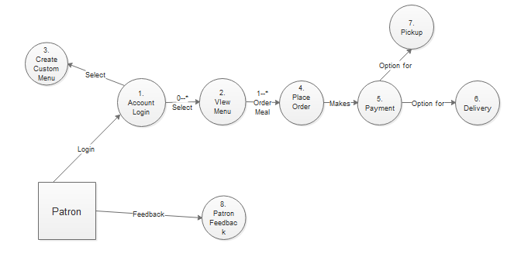

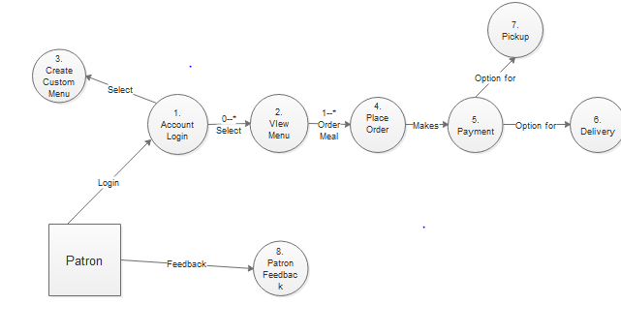

Data flow diagram
- DFD level 0:

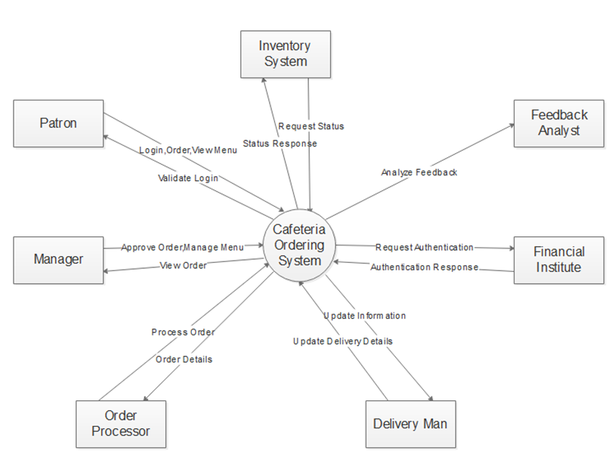
- DFD level 1:

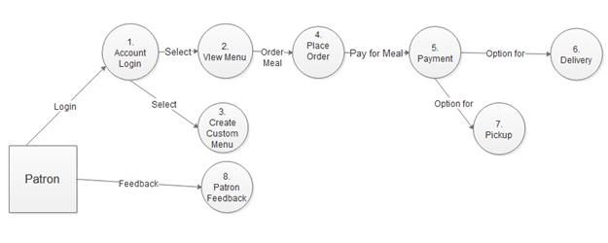

- DFD level 2:

2a.
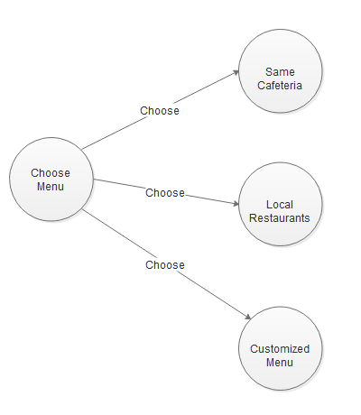
2b.
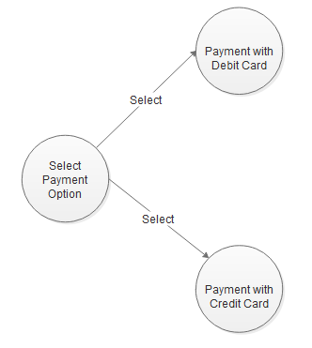

Functional Requirements

FR #1 - Register an account
8.1.1 Introduction: The patron must login to the COS application to order meals.
8.1.2. Inputs: The patron must provide information about him, contact details and card information for payment of ordered meals.
8.1.3 Processing: After the successful login and registration, the patron will have the option to view the menu and order meals, and pay for the ordered meals after the order, meal is delivered.
8.1.4 Outputs: The COS application will provide a user with a notification of successful login into the account.
8.1.5 Error Handling:
8.1.5. E1: If the given username, password does not match, the system generates a message in the COS to the patron that the credentials do not match and login again
8.1.5. E2: If the password does not match, the COS application has an option to update information and change password when forgot.

FR #2 - Place an order
8.2.1 Introduction: The patron will select an item from the list of items available on the COS page
8.2.2 Inputs: The patron will need to have to select a meal
8.2.3 Processing: The patron will choose a meal from the COS and order a meal. The ordered meal is processed by the manager through COS and order is placed. On the successful completion of the order placement, the patron must choose a payment option and pay. The meal is now ordered
8.2.4 Outputs: The system will alert the manager of the order, and the order is prepared
8.2.5 Error Handling:
8.2.5. E1: If there is an error during the payment, the system shall notify the patron that there is a problem
8.2.5. E2: If the meal ordered is not available in the COS, the patron shall be notified of it before the confirmation.

8.3 FR #3 - Pay for meal

8.3.1 Introduction: The patron must select a meal, and then move to the payment options
8.3.2. Inputs: The patron must provide the COS with the details of the debit/credit card for the payment
8.3.3 Processing: Once the card details are entered, the COS application will process it, and the manager will check with the bank, about the transaction. Once there is a clearance from bank, the payment received message will go to the patron.
8.3.4 Outputs: The COS application will generate a message to the patron about the order confirmation
8.3.5 Error Handling:
8.3.5. E1: If the debit/credit card information is not taken by the COS application, the patron must provide additional information and can pay while during the pickup

8.4 FR #4 - Request meal delivery
8.4.1 Introduction: The patron can order meals through COS from local restaurants.
8.4.2 Inputs: The COS application should have the menu from local restaurants and the patron must choose the menu he/she wants.
8.4.3 Processing: After the meal is placed, the COS application checks if the meal ordered is available and if yes, confirmation is sent to the patron and the manager and the order is placed
8.4.4 Outputs: The meal ordered from local restaurant is placed and is delivered or waited for pickup.
8.4.5 Error Handling:
8.4.5.1 E1: The meal ordered by the patron from local restaurant may not be available
8.4.5.1 E2: The payment options chose by the patron may not be suitable for the transaction to be complete.

8.5 FR #5 - Order custom meal
8.5.1 Introduction: The patron has an additional feature in the COS application to make custom menu
8.5.2. Inputs: The patron will have the option to add his custom meal to the menu, in his account in the COS application
8.5.3 Processing: Once the patron orders for a custom meal option in his account through the COS application, the custom meal order is processed and made ready to delivery or pickup for the patron
8.5.4 Outputs: The custom meal ordered is made ready and available to the patron for delivery or pickup
8.5.5 Error Handling:
8.5.5. E1: The custom meal ordered by the patron, may not be available in the store.

8.6 FR #6 - Order customized recipes
8.6.1 Introduction: The patron can provide his own custom ingredients and new recipe methods for customizable meal
8.6.2. Inputs: The patron can provide his own list of ingredients and recipe options to the cafeteria to process the order
8.6.3 Processing: If the given set of ingredients are available in the cafeteria the order is processed
8.6.4 Outputs: After the successful completion of the order, the order is given to the patron and feedback is taken
8.6.5 Error Handling:
8.6.5. E1: If the requested ingredients are not available with the COS, the order cannot be completed and the user shall be notified with the issue
8.6.5. E2: If the patron wants to add additional ingredients to an already existing order, he shall be notified of the extra cost in the total order

8.7 FR #7 - Provide discounts
8.7.1 Introduction: The manager will be updated by the inventory status regarding the food left after the lunch hours. The manager will then provide discounts or offers on that food avoiding the wastage of food
8.7.2. Inputs: The inventory status report will help in providing discounts.
8.7.3 Processing: The manager will provide discounts or offers on the food after checking the inventory status in turn avoiding the wastage of food.
8.7.4 Outputs: After getting the status report the discounts are given.
8.7.5 Error Handling:
8.7.5. E1: if the inventory status is empty the manager does not provide any discount.

8.8 FR #8 – Alter meal subscription
8.11.1 Introduction: The patron can provide meal subscriptions in the application
8.11.2. Inputs: The patron can subscribe for meals for a month by paying the required amount and selecting the option of meal subscription
8.11.3 Processing: After the successful login, the patron will have an option of meal subscriptions for one month in the COS application, and upon payment for the subscription the meal subscription plan is implemented for the user.
8.11.4 Outputs: After successfully choosing meal subscription and payment options, the patron receives a notification stating completion of subscription plan
8.11.5 Error Handling:
8.11.5. E1: If there is a payment problem during subscription for the meals, error notification is displayed to the patron in the COS application
8.11.5. E2: If the patron wants to withdraw the meal subscription plan, the money will be deposited into the patron’s bank account directly for the non-used days of the meal plan subscription.

8.9 FR #9 – Provide system access
8.13.1 Introduction: The patron can access the portal of the COS, within intranet or internet areas and can access it
8.13.2. Inputs: The patron can access the COS, within the intranet or internet access and can order the meals
8.13.3 Processing: After the successful login, the patron can access the cos from intranet or internet and can order the meals
8.13.4 Outputs: The access is granted, and the patron can order meals from the application
8.13.5 Error Handling:
8.13.5. E1: If the patron’s internet or intranet connection is not secured or is interrupted, the order cannot be completed and the information will be stored in the user’s database and can be retrieved when the internet/intranet connection is restored.

8.10 FR #10 – Requesting bulk orders
8.10.1 Introduction: The patron can also request for bulk orders one day prior to the delivery date.
8.10.2. Inputs: The patron can request for bulk orders for occasions like parties, gatherings etc.
8.10.3 Processing: The patron can log into the system and order for the quantity of food he/she wishes to order for. The orders will be taken minimum 1 day prior.
8.10.4 Outputs: The COS application will provide the user with the notification after the order is accepted
8.10.5 Error Handling:
8.10.5. E1: If the order is not placed minimum one day prior the order will not be accepted by the system.

8.11 FR #11 - Provide feedback
8.11.1 Introduction: The customer can provide feedbacks about the meal in the application.
8.11.2. Inputs: After the order is delivered, the patron will login into the account and provide feedback or rating about the food and restaurant which helps improve the service of the system.
8.11.3 Processing: After the successful login, the customer will have an option
of giving feedback about the meal ordered. Once the feedback is given the feedback analyst will analyze it. and make a report and submit it to the manager.
8.11.4 Outputs: The feedback analyst will analyze the feedbacks and make a report and submit it to the manager.
8.11.5 Error Handling:
8.11.5. E1: The feedback can be given by the user only after he logs in to the application else he cannot.

FR #12 – Updating delivery man
8.12.1 Introduction: The manager can update the delivery man about the orders to be delivered and notify him
8.12.2. Inputs: The manager will notify the delivery man about the delivery orders with the addresses and customers information
8.12.3 Processing: The order is processed and updated to the delivery man about the order
8.12.4 Outputs: The manager informs the delivery man about the order and the order is out for delivery by the delivery man and the delivery will start
8.12.5 Error Handling:
8.12.5. E1: If there is a difference in the address mentioned and address available, the delivery man will be updated by the customer
8.12.5. E2: If there is a disturbance in the delivery, the customer should be notified about the delay in delivery

8.13 FR #13 - New recipes using ingredients
8.13.1 Introduction: The customer can provide his own custom ingredients and new recipe methods for customizable meal
8.13.2. Inputs: The customer can provide his own list of ingredients and recipe options to the cafeteria to process the order
8.13.3 Processing: If the given set of ingredients are available in the cafeteria the order is processed
8.13.4 Outputs: After the successful completion of the order, the order is given to the customer and feedback is taken
8.13.5 Error Handling:
8.13.5. E1: If the requested ingredients are not available with the COS, the order cannot be completed and the user shall be notified with the issue
8.13.5. E2: If the customer wants to add additional ingredients to an already existing order, he shall be notified of the extra cost in the total order

  - FR #14 - Order meals from local restaurants

8.14.1 Introduction: The customer can order meals through COS from local restaurants.
8.14.2 Inputs: The COS application should have the menu from local restaurants and the customer must choose the menu he/she wants.
8.14.3 Processing: After the meal is placed, the COS application checks if the meal ordered is available and if yes, confirmation is sent to the customer and the manager and the order is placed
8.14.4 Outputs: The meal ordered from local restaurant is placed and is delivered or waited for pickup.
8.14.5 Error Handling:
8.14.5.1 E1: The meal ordered by the customer from local restaurant may not be available
8.14.5.1 E2: The payment options chose by the customer may not be suitable for the transaction to be complete.

  - FR #15 - Create and updating menu

8.15.1 Introduction: The COS application has an option to create and update new menu and modify menu’s
8.15.2. Inputs: The manager has an option to create and update new menus and existing menu using the COS application
8.15.3 Processing: Once the COS application is opened and the manager has the feature to update the existing menu and can update it in the application.
8.15.4 Outputs: After the menu is updated the user can view the new modified menu in the application.
8.15.5 Error Handling:
8.15.5. E1: If the menu is updated and not saved, the updated menu will not be displayed in the application and will provide the user with the information that update is not successful and has to re update the details

FR#16 - Evaluate inventory status

8.16.1 Introduction: The COS application has a feature of keeping a track about the inventory status.
8.16.2. Inputs: The manager has an option to keep a check on the inventory and provide additional discounts.
8.16.3 Processing: The manager evaluates the inventory and provides discounts on the food items that are available in bulk to avoid wastage of food.
8.16.4 Outputs: The COS application will display the offers and discounts informing the users about the discounts.
8.16.5 Error Handling:
8.16.5. E1: If there aren’t any food items in the inventory then the discounts won’t be provided. If it is still displayed on the COS application and the patron chooses it, the order won’t be successfully placed.

8.17 FR#17 - Creating Personal menu

8.17.1 Introduction: The customer can create their own personal menu in the application
8.17.2. Inputs: The customer can create his own personal menu by selecting the items and ingredients
8.17.3 Processing: After the customer provides the custom personal menu by selecting the ingredients and items, the order is processed and the end order is delivered to the customer by delivery/ pickup option.
8.17.4 Outputs: The COS application will provide the user with the notification after the order is ready
8.17.5 Error Handling:
8.17.5. E1: If the ordered ingredients and items are not available in the restaurant, the COS application will notify the user of the non-available ingredients and provides an option to
choose from other available ingredients.

Sequence diagram

- Register account, Place an order, Provide order details, Request bulk order
(Use case: 1, 2, 10, 12)

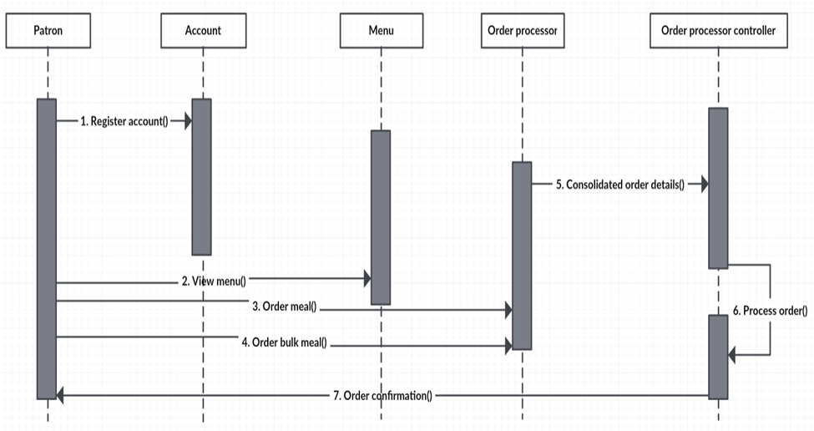

- Alter meal subscription (Use case: 3)

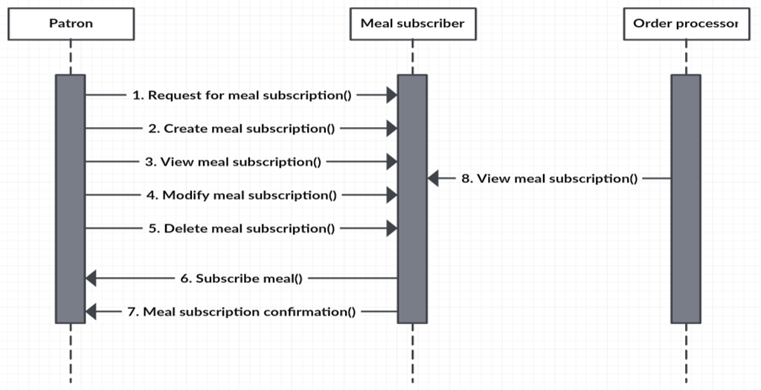

- Pay for meal, Process payment (Use case: 4, 14)

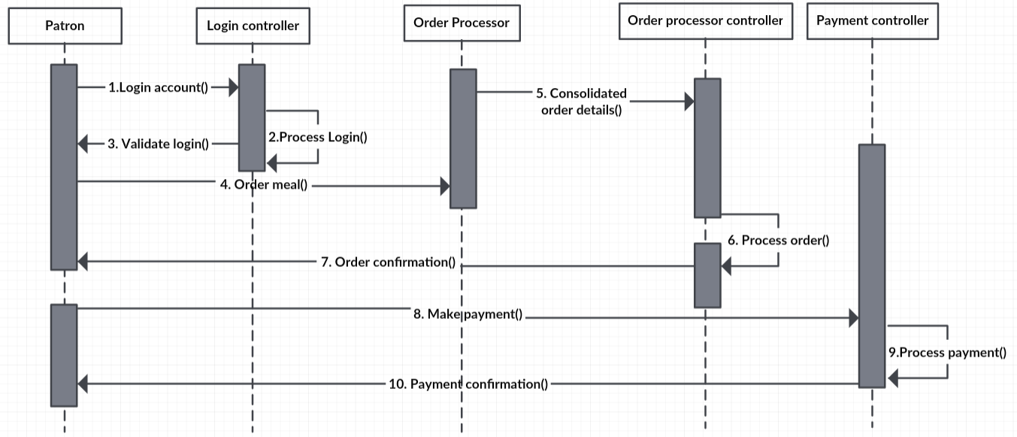

- Request meal delivery, delivery meal (Use case: 5, 17)

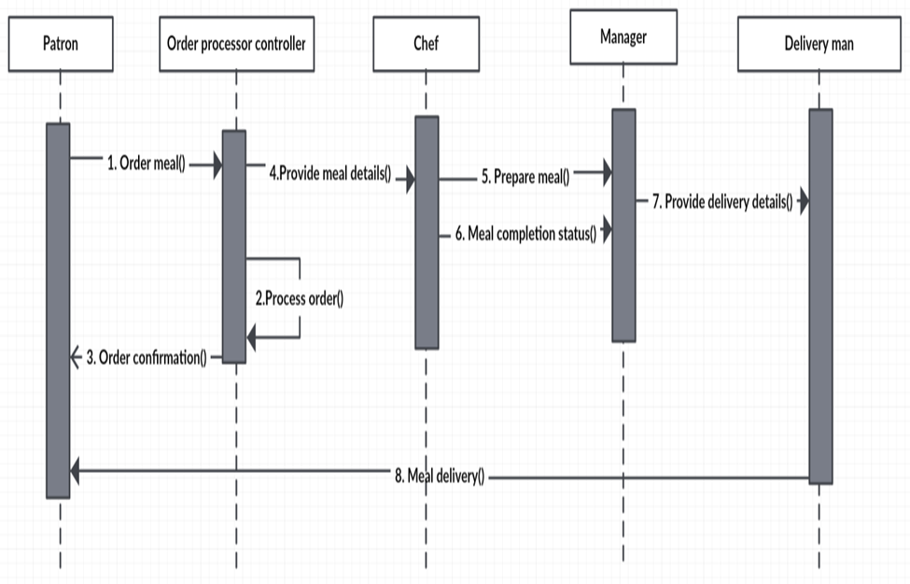

- Alter menu (Use case: 6)

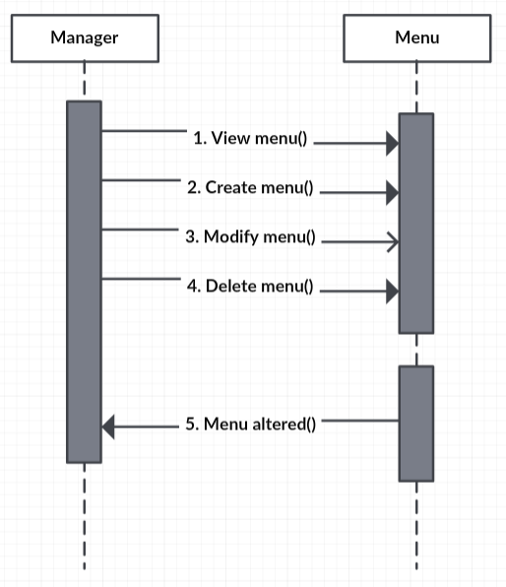

- Order meal from other restaurant (Use case: 7)

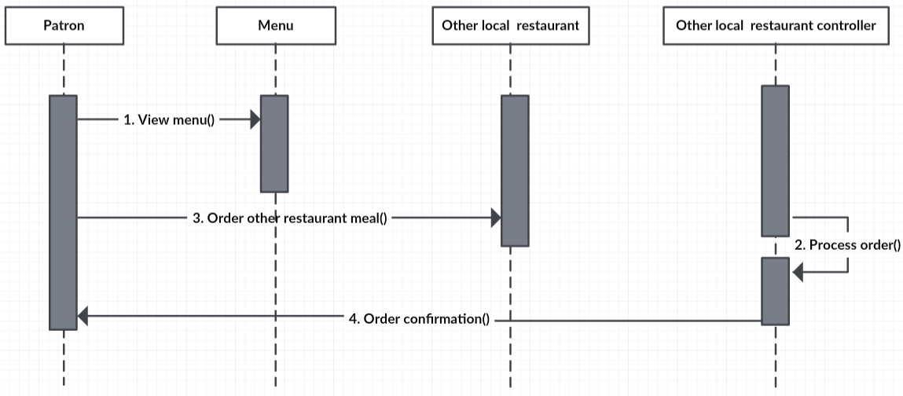

- Order customized recipe meal (Use case: 8)

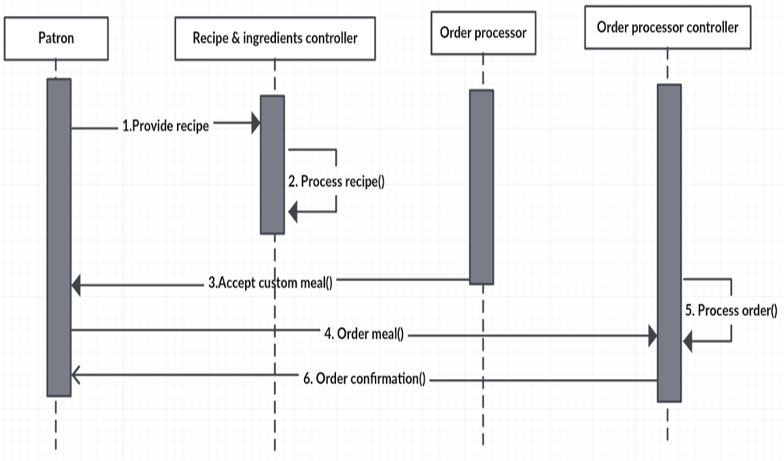

- Provide discounts (Use case: 9)
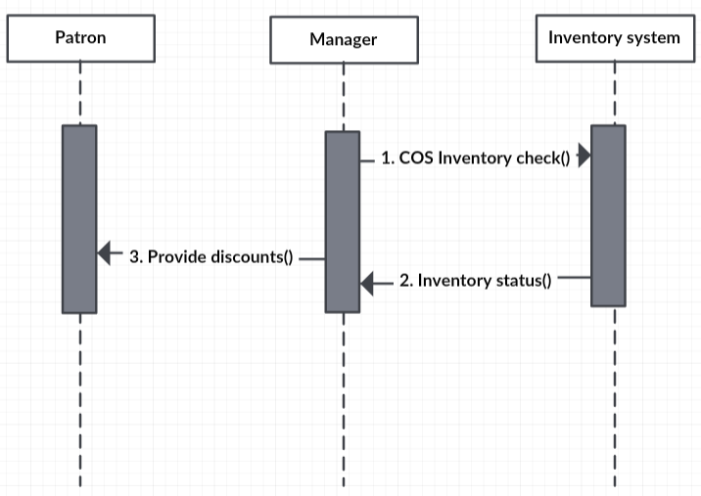

- Provide employee access (Use case: 11)

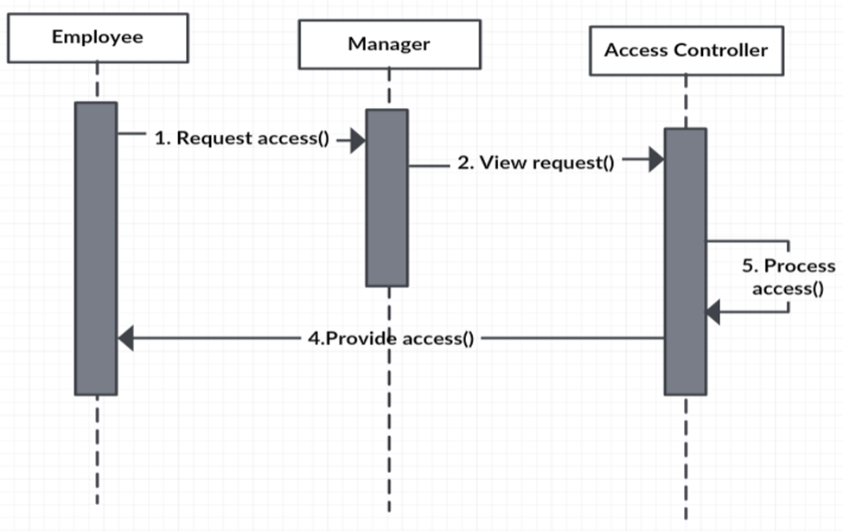

- Provide feedback (Use case: 13)

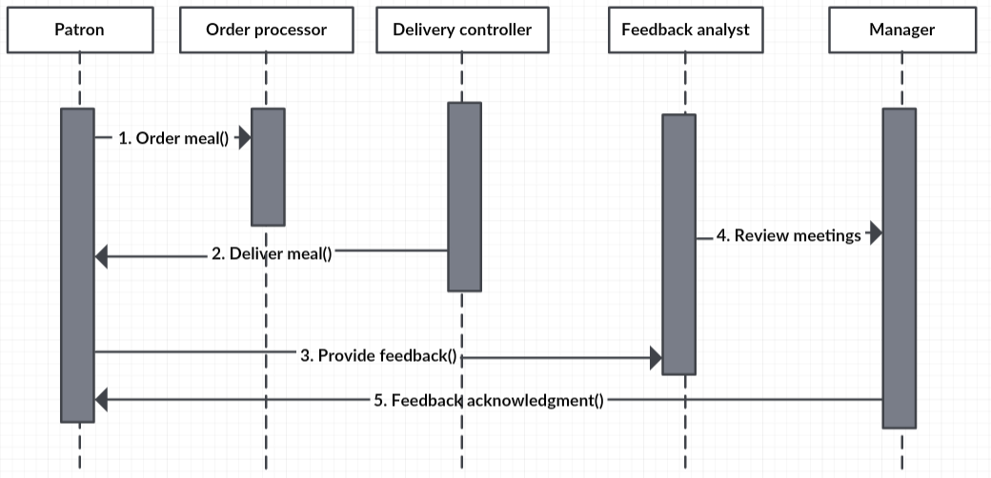

- Evaluate Inventory status (Use case: 15)

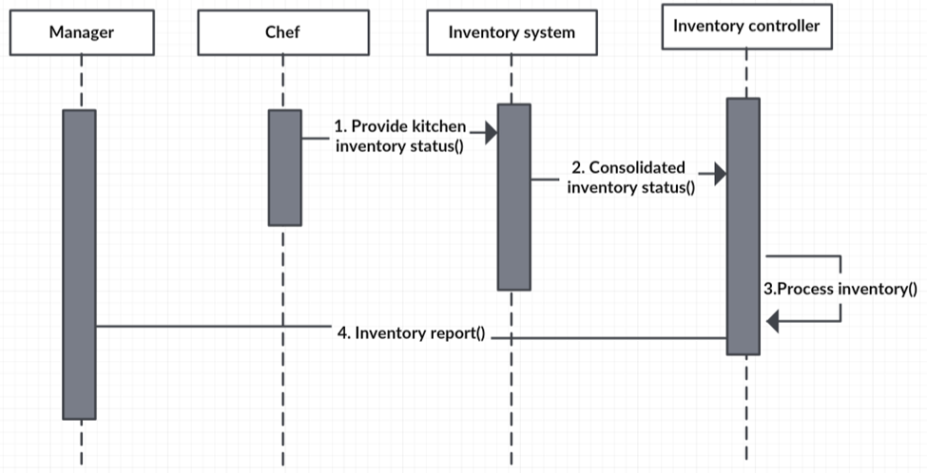

- Prepare meal (Use case: 16)

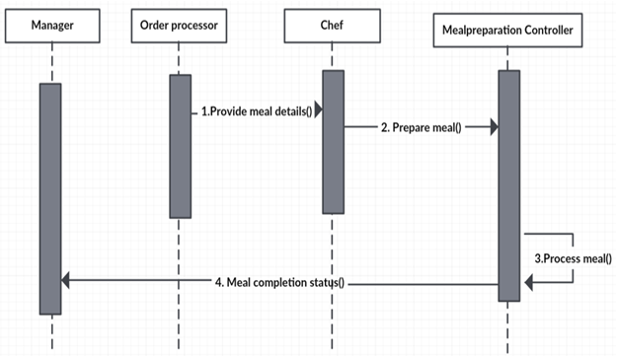

Class Diagram

Initial class diagram

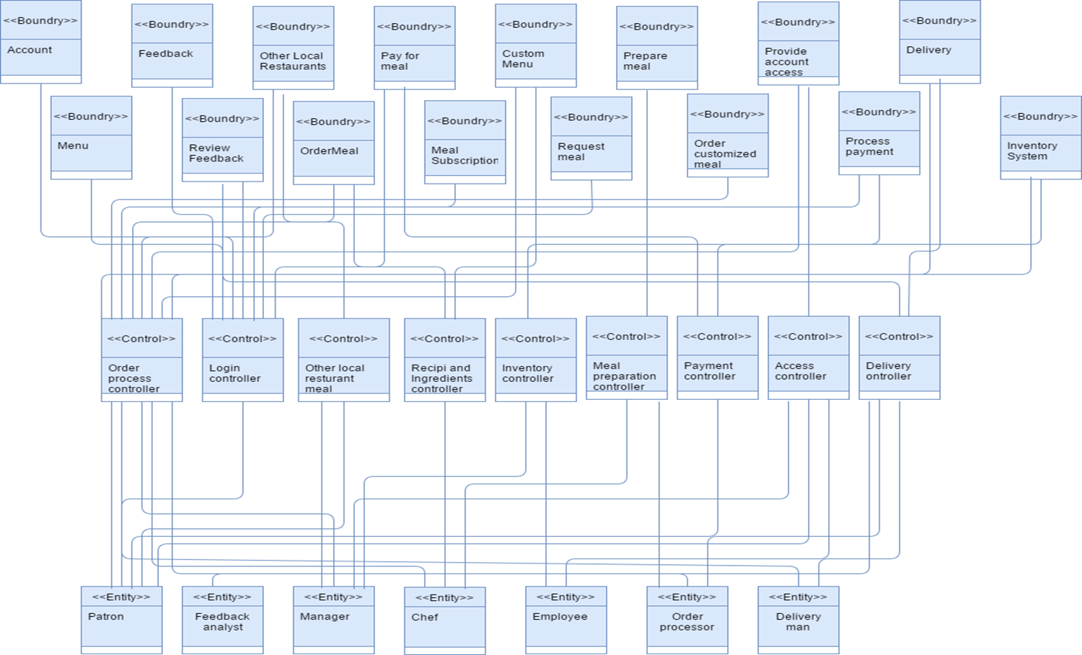

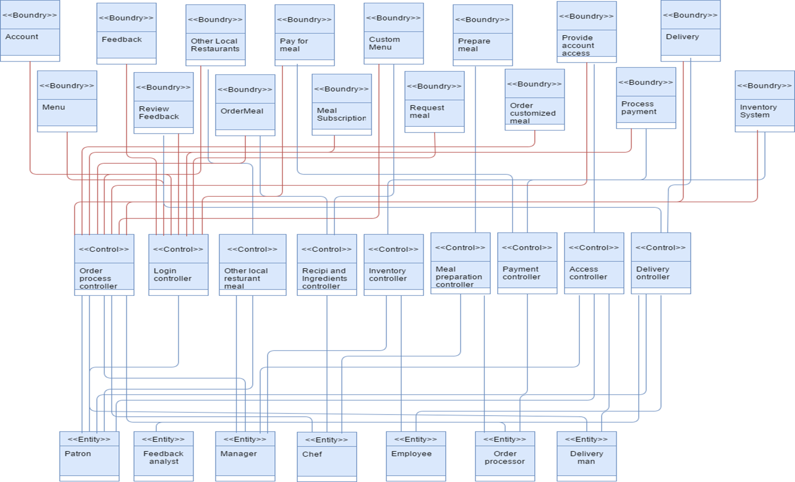

Modified Class Diagram

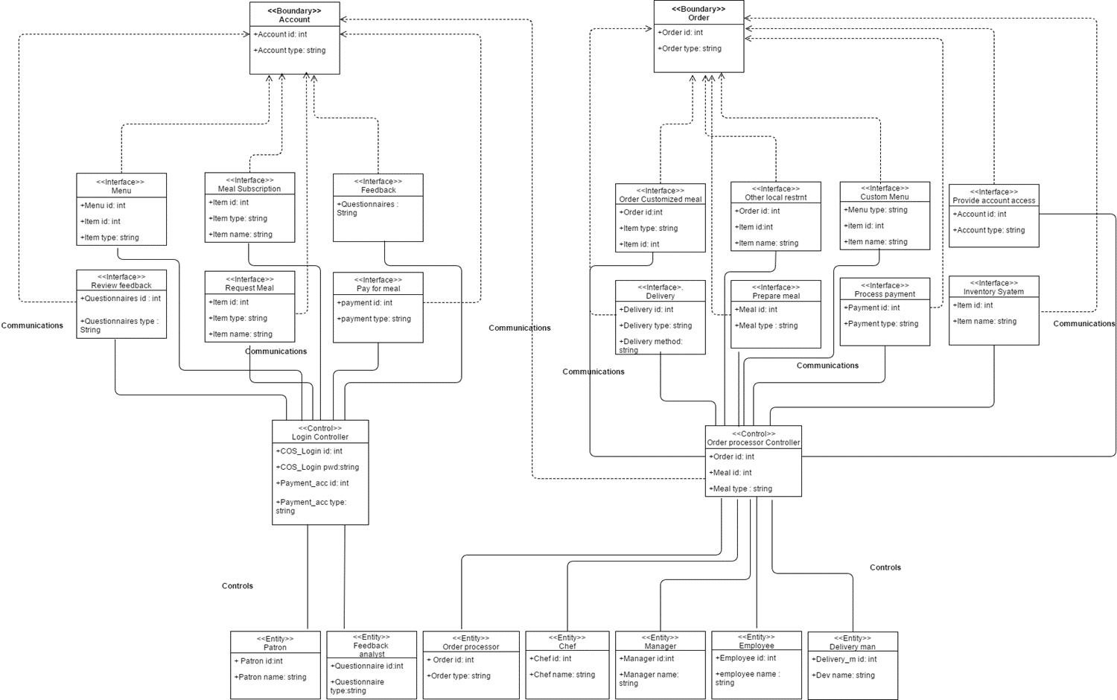

Detailed class diagram

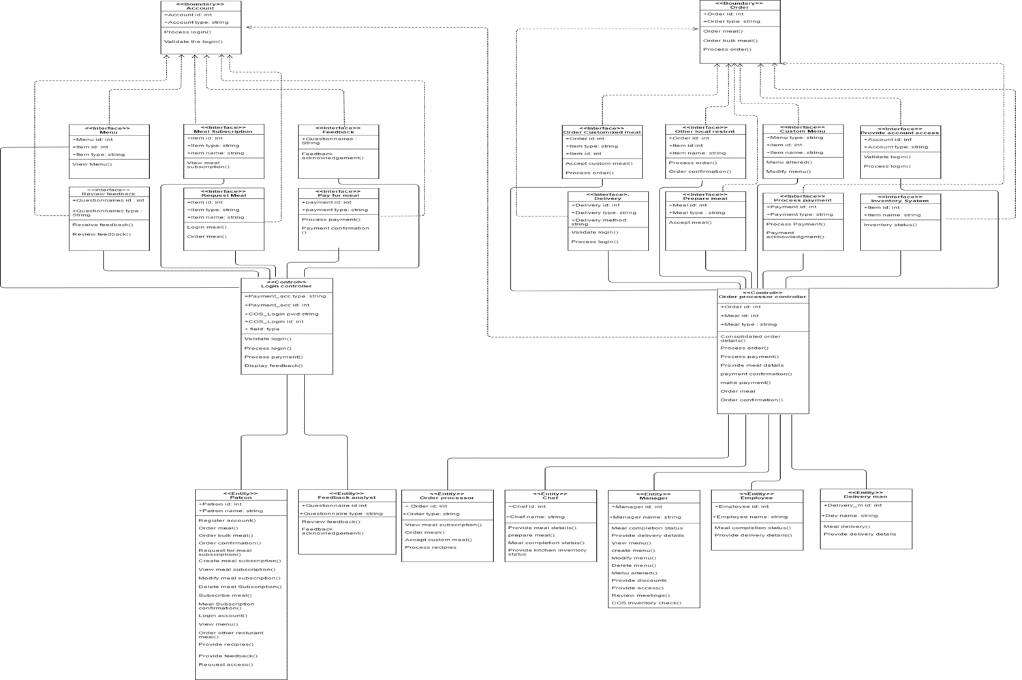

Part 1(clear view of each classes): Connection of the entities to the Login Controller

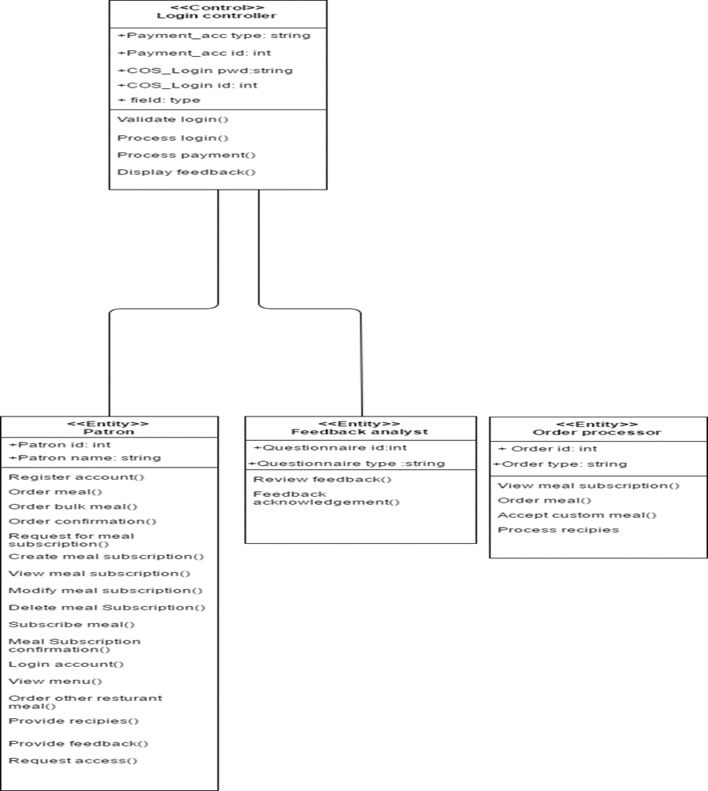

Part 2: Connection from the Login controller to the Account Boundary class

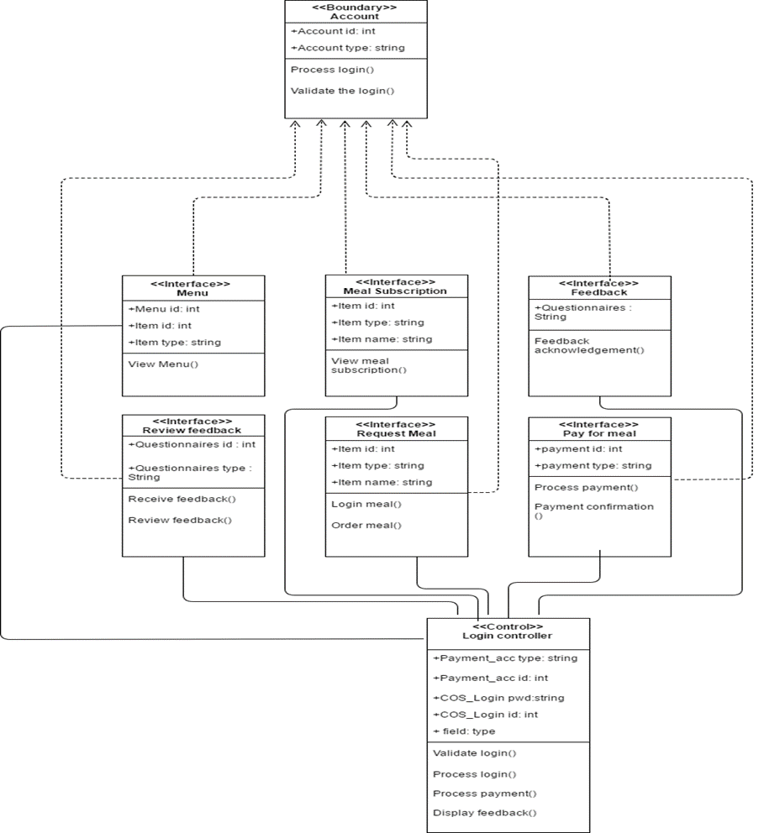

Part 3: Connection from all th entities to the Order processor controller

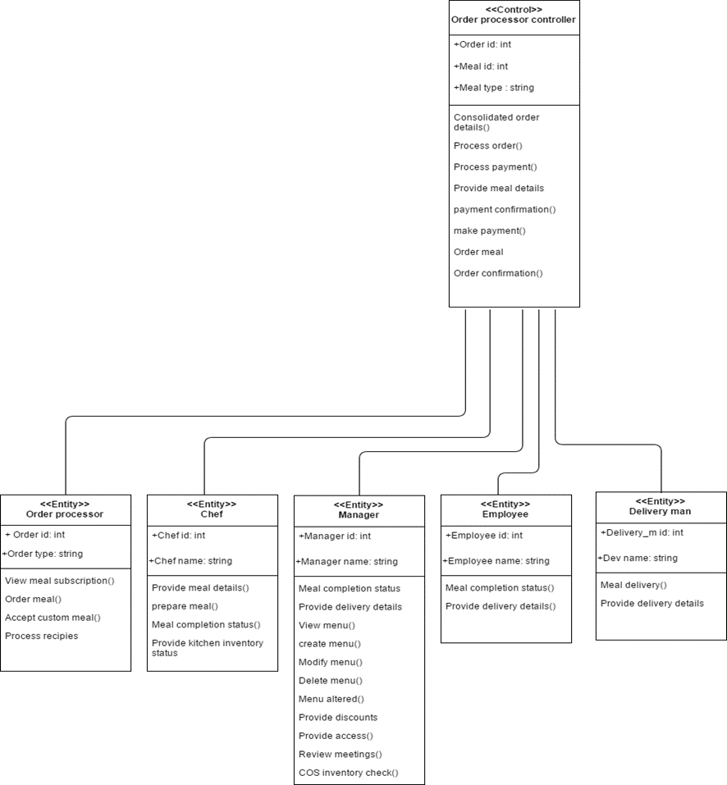

Part 4: Connection from the Order processor controller to the Order boundary class

